The Yggdrasil Memory Architecture:

A Governed Memory System for Long-Term Adaptive Agents

Benjamin Thompson
December 2025

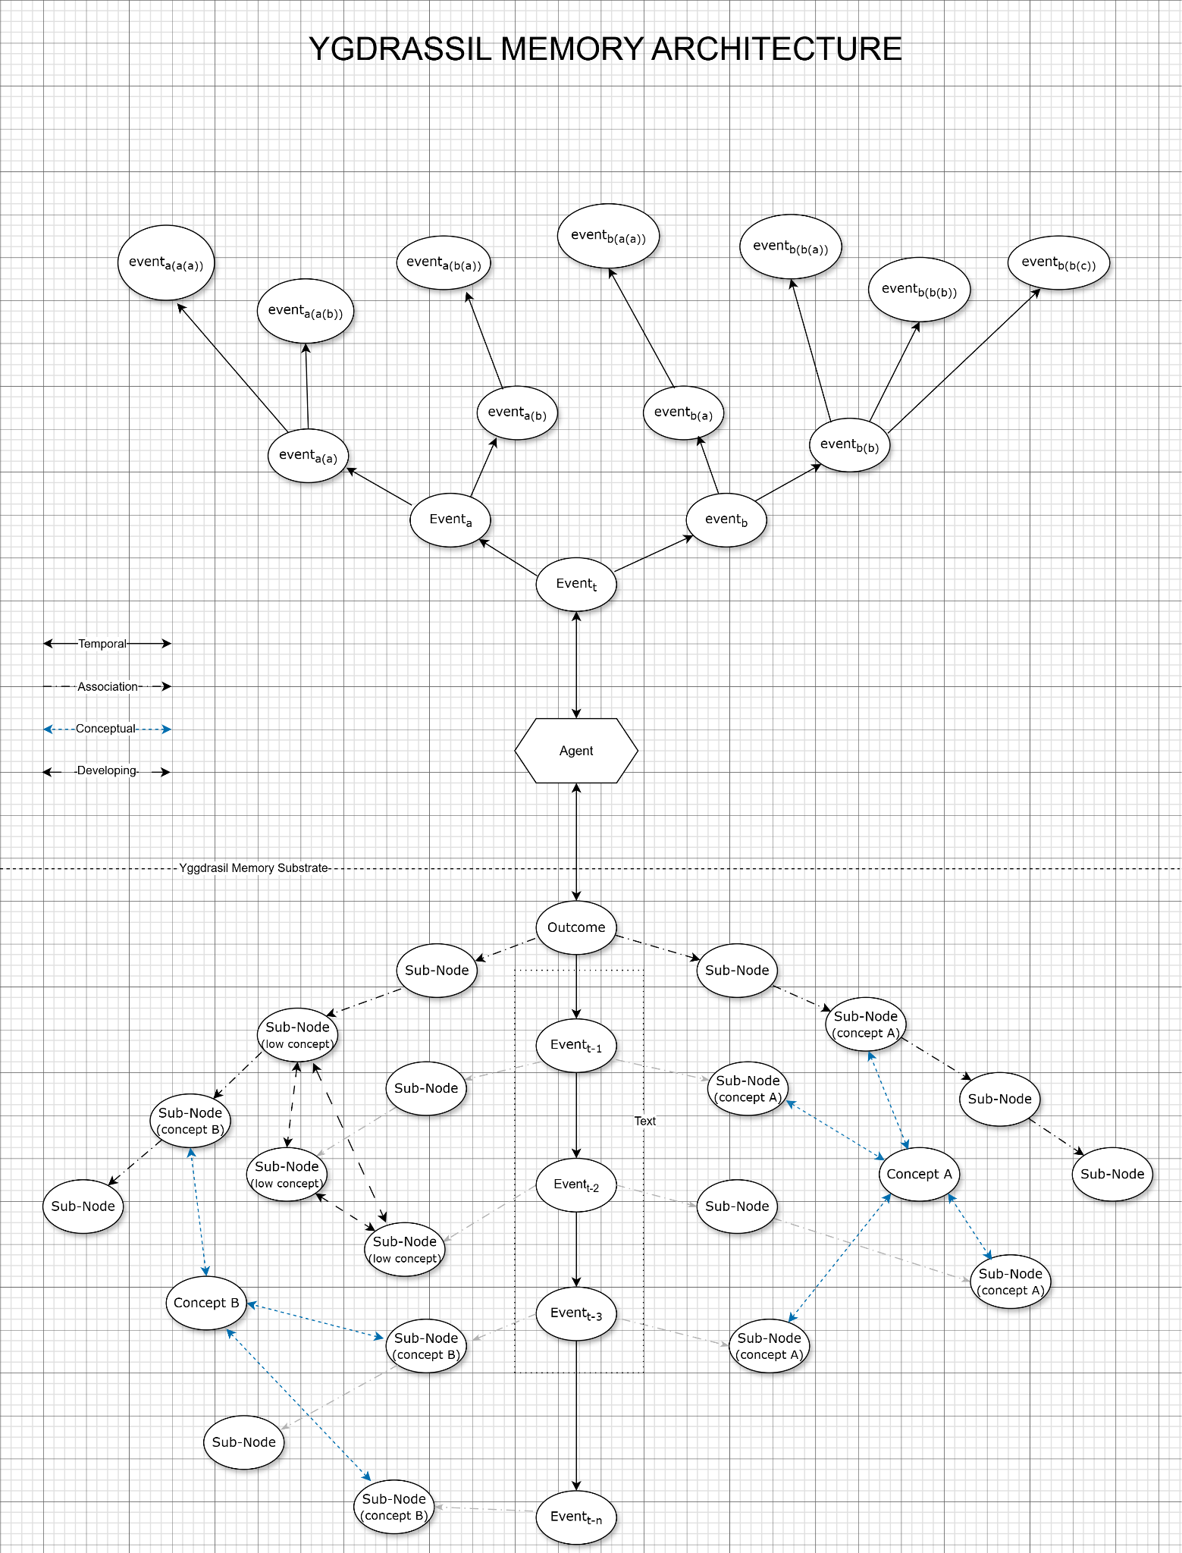

---------------------------
0. Abstract
---------------------------

Modern language models and agentic systems still lack a coherent mechanism for long-term memory. Popular solutions, such as vector databases, retrieval-augmented generation, scratchpads, or extended context windows, treat memory as external storage and retrieval, not as an evolving internal structure. As a result, agents cannot form stable identities, cannot reliably improve through experience, and cannot be audited or replayed with deterministic clarity.
In this paper I introduce the Yggdrasil Memory Architecture (YMA), a governed memory system that represents an agent’s experience as an adaptive graph of events, episodes, concepts, and outcomes. Each node and edge in the memory store is continuously shaped by three interacting quantities: salience (current importance), permanence (long-term stability), and decay (tendency to fade). Outcomes of actions modulate these values across the structure, causing successful trajectories to be reinforced and harmful ones to be encoded with high permanence and slow decay. The architecture is event-sourced and bounded, enabling deterministic replay of an agent’s internal state at any point in time while maintaining a healthy, pruned memory.
On top of this substrate, the architecture supports both short-term episodic buffering and a meso-level reflective process that periodically re-examines similar, high-salience episodes, both positive and negative, to adjust long-horizon behavior. This allows agents attached to the system to favor intermediate decisions that historically lead to robust outcomes, rather than greedily chase short-term gains. I present the core data model, update dynamics, and interaction API, along with pseudocode for a minimal reference implementation. The YMA is proposed as a foundation for building agents that are not only powerful in the moment, but coherent, interpretable, and self-correcting over time.

-------------------------------------------------------------------
1. Introduction and Motivation
-------------------------------------------------------------------
You wouldn’t be “you” without memory.
Everything about how we think - identity, preference, intuition, the sense of being the same person from one moment to the next, it all rests on how memory is organized and how it changes over time. A mind without governed memory isn’t really a mind; it’s a stateless reaction machine. What separates intelligence from pattern-matching isn’t raw compute or a more refined embedding distribution; it’s the ability to accumulate experience, reinforce what matters, forget what doesn’t, and reinterpret situations in light of everything learned so far.
Consider how a child learns to distinguish birds. At first, everything with wings is simply “bird.” But as they encounter sparrows, crows, and hawks—in different contexts, colors, and behaviors—their internal model reorganizes itself:
- connecting similar observations
- forming increasingly stable concepts
- correcting mistaken assumptions
- weighting certain experiences more heavily than others
- and gradually treating reliable distinctions as meaningful
This is an evolving structural understanding, allowing for larger conceptual connectivity.
Modern AI systems cannot do this. They can retrieve similar examples, but they cannot refine their internal world model across time. They do not update, reorganize, or stabilize their understanding of a concept the way even a young child naturally does.
LLMs and the agent frameworks built around them operate with a kind of forced amnesia: every choice they make is mostly disconnected from the last one unless you manually stuff text into a context window or pipe embeddings into a vector store. These tools can retrieve information, but retrieval is not the same as memory. They have no sense of continuity, no evolving internal model of their environment, no stable representation of lessons learned, and no reliable way to explain why one decision follows from another.
What we have instead is a collection of workarounds—vector DBs, RAG pipelines, token-extension tricks, scratchpads—surrounding the missing component everyone implicitly depends on. These tools solve narrow problems, but none provide a true memory layer. Without a governed structure beneath an agent’s reasoning process, it’s difficult to achieve reliable improvement over time, stable behavioral tendencies, or any form of determinism in replaying past decisions.
If intelligent behavior depends on the interaction between memory and perception, and much of cognitive science points in that direction, then building agents without a structured, adaptive memory system imposes hard limits on their stability. They tend to remain brittle and short-lived unless memory is treated as a first-class architectural concern rather than an afterthought.
This paper presents a framework designed to address that missing layer: a bounded, event-sourced, outcome-shaped memory architecture that acts as the long-term experiential backbone for artificial agents. Instead of treating memory as a flat store of facts, it models experience as a dynamic graph with its own update rules, weighting mechanisms, and stability constraints. Events carry attributes—salience, permanence, decay—and the structure of memory shifts as the agent interacts with its environment and encounters consequences.
The goal is not to simulate biology, but to borrow the functional aspects of memory that enable continuity and identity. The architecture enables agents to stabilize useful behaviors, encode harmful outcomes with lasting clarity, and gradually form a sense of “what matters” based on accumulated interactions. Every change is deterministic and replayable; nothing is hidden inside a black box.
In short: if we expect agents to behave coherently across long horizons, retrieval tricks and unbounded logs won’t be enough. They need a real memory architecture. The data model introduced in this paper, the Yggdrasil Memory Architecture, is an attempt to formalize and implement that missing component.
----------------------------------------------
Design Philosophy
----------------------------------------------
The Yggdrasil Memory Architecture is built around a simple premise:
an intelligence cannot behave coherently over time if its memory is an afterthought.
Where many modern AI systems emphasize scale, optimization tricks, or increasingly complex architectures, the YMA takes a different stance. It begins with the idea that structure matters. The way experience is represented determines what an agent can learn from it, how it generalizes, and whether it remains stable as the environment shifts. Several principles guided development of the architecture:

Memory should evolve only through experience.
The substrate doesn’t update because a gradient nudged it, or because a prompt asked it to. It updates because something happened: an event was observed, or an outcome occurred. Through usage and analysis, a retrieval can reinforce a pattern, or a long-horizon correction can be discovered. This makes the system grounded and inspectable.

Forgetting is necessary for proper remembrance.
Infinite memory is not desirable, as healthy cognition relies on decay, pruning, and prioritization. When flooded with data, memory instead becomes dissonance. A meaningful memory system should forget:
- the irrelevant
- the redundant
- the misleading
- the outdated
and preserve what experience repeatedly shows to be important, while allowing for the capability to rewind, reset, or forget misaligned data entirely.

Consequences should shape structure.
Not all events are equal, and memory requires a means of affirming what is important to the agent. Events that carry meaningful outcomes, especially failures, should leave deeper marks on the substrate than trivial observations. This mirrors real learning: the world teaches us what to care about.

Abstraction is emergent.
Concepts, episodes, and high-level structures shouldn’t be defined by human engineers.
They should form themselves as patterns accumulate repeated co-occurrences across correlated experiences, stable transitions from one state to another define temporal shifts, long-horizon relationships that belay instinctive or immediate risk/reward interplay are discovered, or consistent causal structures are found and conceptualized. The architecture is designed to let these abstractions surface naturally. As the agent interacts with the varied environments it is part of, new knowledge and structures for cognitive analysis will emerge through repetition, reinforcement, and pruning of unnecessary or noisy memory.

Memory must be interpretable and replayable.
Opaque mechanisms can be powerful, but they are difficult to trust. The YMA is intentionally event-sourced, deterministic, inspectable, and explainable. Any decision can be traced back through the memory structure to the evidence that shaped it, thereby allowing for human governance to alter the state of the structure for expected results.

The substrate must be stable and dynamic.
A healthy cognitive system adapts without collapsing. The architecture encourages slow, corrective change, while maintaining flexibility for explorative solution seeking. Recent experiences influence the structure of memory, but deep, high-permanence knowledge remains stable and the meso-layer, which I will explain in further detail later in this paper, periodically smooths out overreactions, mistaken causation analysis, and patterns of behavior that are brittle. This balance prevents both rigidity and chaos, by steeping the actions, interpretations, and knowledge base of an agent in an experientially sourced data model.

Agents should develop identity, not personality templates.
The architecture doesn’t impose “modes,” “personas,” or scripted behaviors.
Identity arises naturally from:
- accumulated experience
- reinforced preferences
- stable aversions
- long-horizon adjustments
- evolving conceptual structure
This gives each agent a coherent internal worldview, even if two agents start from the same seed state. This would also allow for memory optimization, experimentation on how narrative and experience affect intelligent action or inaction, and so on.

Safety is an internal property, not bolt-on tooling.
Because consequences, permanence, and reflective auditing are built into the substrate, many forms of misalignment become ordinary memory dynamics rather than special-case patches. Safety is achieved by shaping how memory updates, not by enforcing behaviors through rule layers that may become brittle as information or situations change.
A static model of knowledge is always incomplete in an open-ended universe, just as any finite list of primes is incomplete. Only a governed, experience-driven memory substrate can continuously generate and integrate novel abstractions that lie outside the original embedding distribution..
The Yggdrasil Memory Architecture is an attempt to build the missing layer that makes long-horizon cognition possible, by allowing experience to develop.

-----------------------------------------------------------------------------------
2. Limitations of Current Approaches
-----------------------------------------------------------------------------------

Artificial memory systems are built around a quiet but pervasive assumption: that “memory” is just the ability to retrieve information. It sounds reasonable until you try to build an agent that needs to behave coherently for longer than a single prompt. The difficulty arises because memory is structural, it changes what the system is, rather than augment a reasoning process.
Below, I outline why the standard memory patches fail to behave like memory at all, and why none of them can serve as the substrate for adaptive agents.

Vector Databases and Embeddings
Vector search is excellent for similarity lookup, but storing embeddings as “memory” produces immediate limits:
- No temporal continuity. Nothing encodes sequence or history.
- No permanence or decay. Everything lasts forever unless manually removed.
- No salience. Critical failures and trivial observations are treated identically.
- No identity formation. Experiences remain isolated points, not trajectories.
- No deterministic replay. You cannot reconstruct what the agent “knew” at any prior moment.
Vector DBs are retrieval systems. They are not mechanisms for shaping experience or expertise over time. Because they accrue without pruning, over long periods of time, a vector database will introduce noise, unless maintained specifically.

Scratchpads, KV Caches, and Long Context Windows
Larger working memory is still working memory:
- Bounded capacity without structure. A bigger window is still a window.
- Forgetting is arbitrary. Old content simply falls out.
- No cross-episode persistence. When the task ends, the “memory” vanishes.
- No integration into worldview. The model doesn’t change — only the prompt does.
This is a whiteboard, not a long-term memory system. Useful, but not inherently structural.

Retrieval-Augmented Generation (RAG)
RAG improves recall, but it never mutates itself. It remains static no matter what happens:
- Static store. Nothing changes in response to outcomes.
- External weighting. Relevance must be engineered, not learned.
- No causal feedback. Success and failure don’t reshape internal structure.
- Inconsistent recall. Small embedding shifts can produce different retrievals.
- No sense of trajectory. A sequence is flattened into a bag of text chunks.
RAG expands information access — it does not create memory.

Logs, Journals, and “Agent History” Buffers
Appending every action to a running log “feels” like continuity, but collapses quickly:
- Unbounded growth. Logs accumulate until manually trimmed.
- No compression. Redundant patterns repeat endlessly.
- No governed pruning. Nothing fades or demotes itself.
- No structure. Text streams do not form a cognitive representation.
- Poor queryability. They are transcripts, not understanding.
Archival is not memory. In practice, raw logs degrade performance by accumulating noise.

Reinforcement Learning Replay Buffers
Replay buffers resemble memory more than most tools, but still fall short:
- Naive boundedness. FIFO drop-off ignores importance.
- No permanence. Major events disappear when the buffer rolls over.
- No salience modulation. Everything is uniformly weighted unless heavily engineered.
- No structure. Transitions are tuples, not connected experiences.
- No inner history. They support optimization, not identity or continuity.
Replay buffers train models; they do not shape behavior dynamically as it unfolds.
All these approaches fail for the same fundamental reason:
There is no mechanism that governs what is kept, what is forgotten, what becomes important, or how experience reshapes internal structure.
Human memory has implicit rules for this, but artificial systems do not yet have a corollary. Without governance, memory either bloats uncontrollably or collapses, relevance becomes arbitrary, harmful patterns persist. There is no stable compass for long-term behavior, so behavior is just as varied as specific input scenarios. Adaptive intelligence cannot emerge from an unguided storage system.

Closing Limitations of Current Approaches
We’ve reached a strange point in the field: massively capable models, increasingly sophisticated agent stacks, endless tooling—but still no memory system that behaves like memory. Everything we have is retrieval-oriented rather than cognition-oriented.
What is missing is not a fancier embedding search, or more tokens, or a better log rotation strategy.What is missing is a memory substrate. The next section introduces such a system: a bounded, event-sourced, outcome-shaped graph designed to serve as the backbone for stable, auditable, adaptive artificial cognition.
---------------------------------------------------------------------------------------
3 The Memory Substrate: Core Data Model
---------------------------------------------------------------------------------------
The substrate is a bounded, event-sourced, continuously evolving graph that captures the agent’s lived experience. The structure of the graph doesn’t remain static or grow one dimensionally, it reorganizes itself based on significance, consequences, and recurrence. The point isn’t to hoard information; the point is to create a coherent internal world that reflects the nature of the agent’s experiences.
The substrate exists to do three things:
- Preserve meaningful history in a form that creates continuity rather than clutter.
- Adapt its structure based on what actually happens to the agent.
- Provide stable context to whatever models or controllers sit above it.
Everything else emerges from those three responsibilities.
The rest of this section lays out the core data model—the types of nodes and edges, the attributes that guide adaptation, and the rules that keep the substrate healthy.

Node Types
The substrate expresses memory through a few simple node types. These are meant to be flexible, and can be extended later, but this minimal set is enough to support continuity, abstraction, and learning.
Event Nodes
Event Representation.
Yggdrasil does not prescribe a single event schema. Events are defined at the boundary where raw experience is parsed into meaningful structure. In chat-based agents, an event may correspond to a full user–agent exchange; in sensor-driven systems, to a perceptual slice; in reasoning agents, to an inference step. What matters is not the format, but the fact that the event contains:
- the observations or content of the experience
- the agent’s action or response
- the associated outcome
- a set of sub-node candidates extracted from embeddings or semantic structure
The substrate interprets these elements into its internal graph, forming the foundation for salience, permanence, decay, and conceptual density. These are the raw atoms of experience—single observations, actions, or state changes.
Some typical examples could include but are not limited to: a user interaction,an internal decision via the agent, environmental signals, or a model output the agent committed to.Each event node carries, at a minimum:
- timestamp
- event type
- payload or embedding
- salience
- permanence
- decay rate
- outcome hooks for later updates
Events are not “stored facts.” As the building blocks of what happened, they contain information relevant to the experiential continuum of the agent and thereby allow for abstraction through latent concept connectivity.

Outcome Nodes
Outcome nodes are key to the structure and flow of experiential data in the memory graph. Although there is no single prescribed method for detecting outcome boundaries, common indicators include:
- success or partial success
- perceived failure
- churn or user backlash
- profit, risk shifts, or financial reward
- penalties or corrective signals
Outcome nodes are the primary drivers of adaptation within the substrate. They directly modulate salience, permanence, and decay across the memory structure.
By marking what went well and what went poorly, outcome nodes establish cluster boundaries and provide the causal links that connect sequences of events to their real-world consequences. In doing so, they anchor experience in a way that remains both scalable and governable.
.
Episode Blocks/Chunks
Episodes group short sequences of events into a coherent unit. They’re formed when the short-term buffer commits something that was determined to be meaningful or complete enough to deserve structure.
Episodes give you:
- compression
- temporal abstraction
- better retrieval
- the ability to reason over trajectories rather than individual steps
By grouping series of events together with outcomes, episodes allow for more expedient pattern matching and concept abstraction, while the three factors of forgetfulness will trim information that is deemed mechanistically unimportant over time.

Concept Systems
In this architecture, concepts are not fixed symbols or neatly carved categories. They grow the same way they do in human cognition: slowly, through repetition, context, and the accumulation of meaningful distinctions. A concept only becomes stable because the system keeps encountering something that matters in roughly the same way across different situations.
A concept can start as nothing more than metadata- “yellow,” “hesitation,” “two steps back,” “high cost” that can be attached to an event. If that marker keeps showing up in contexts that influence outcomes, it stops behaving like a surface detail and begins to act like a structural anchor. The substrate starts drawing lines between every place that idea appears, and a small region of meaning begins to take shape. Over time, it becomes a concept in the real sense: something the system leans on to interpret new situations.
Concepts aren’t constrained to a single level of abstraction. The same detail can behave as a trivial property in one moment and as the backbone of a generalization in another. A color like “yellow” might first appear as a simple object feature, something seen, nothing more. But if it reliably appears in the presence of caution, warnings, or elevated stakes, the substrate reinterprets it. “Yellow” becomes a signal, not just a color, and future events inherit that bias unless experience overturns it. This is the architecture’s way of revising meaning without anyone explicitly telling it what a thing “should” mean.
This is where conceptual density enters the picture. As seen in the diagram on page 24, as a concept accumulates connections, whether it may be events that reference it, subnodes that depend on it, episodes that hinge on it - its structural weight increases. Dense concepts sit at the center of many relationships; removing them would fracture the graph, and introduce dissonance, while sparse or transient concepts behave more like passing impressions. Density differentiates the abstractions the agent genuinely relies on from the ones it brushes past. It also gives the system a principled way to decide which conceptual structures should survive pruning and which should naturally dissolve.
Because concepts form through the same salience, permanence, decay, and density dynamics as everything else in memory, they’re always in motion. They strengthen when they help the agent explain or anticipate outcomes. They fade when they fail to matter. They reorganize when the meso-layer notices long-horizon relationships the event loop can’t see. Nothing about them is frozen or manually maintained; their shape reflects the lived experience of the agent.
Concepts also function as the substrate’s core mechanism for abstraction. Once the system has seen enough episodes that differ in superficial details but share an internal structure, it begins to form a shared conceptual scaffold that ties them together. These abstractions are not predefined categories—they emerge organically from repeated regularities, familiar transitions, and persistent relationships.
In this way, concepts become the connective tissue of the architecture. They bridge events and episodes. They carry meaning forward. They allow the agent to reinterpret new experiences through the lens of what it already knows. Concepts make generalization possible, but more importantly, they make meaning stable without making it rigid.
A concept in Yggdrasil is not a label. It is an adaptive structure with a gravitational pull, shaped by salience, permanence, decay, and especially conceptual density. It evolves as the agent evolves, and it anchors the abstractions that make coherent cognition possible.

Feature Nodes (Sub-Nodes)
Events rarely arrive as clean, atomic units. They’re made of pieces—objects, properties, signals, affordances, and contextual details that give the event shape. Treating an event as a flat record hides most of the structure that actually matters. To address this, the architecture introduces feature nodes (or sub-nodes): the internal components of an event that preserve the meaningful elements that compose the experience.
A feature node can represent anything the agent encounters inside an event:
- a physical or digital object
- a property or attribute (color, sound pattern, temperature, texture)
- a relational cue (“next to,” “caused by,” “responding to”)
- a contextual element (location, interface state, environment)
- a semantic detail the model extracts during interpretation
The important part is not the taxonomy but the function. Feature nodes give the substrate a finer resolution of memory without changing the core structure of the graph. Instead of relying on descriptions embedded in metadata, the system treats the components of an event as first-class memory elements, capable of forming their own links, receiving salience updates, and participating in conceptual emergence.
Over time, this creates a natural connectivity between raw experience and high-level abstraction. For example, if the agent repeatedly encounters yellow objects in situations tied to caution or failure, “yellow” is no longer just a color tag in metadata—it becomes a structured feature node that carries salience, participates in outcomes, and eventually feeds into a more general concept the substrate forms about warning signals. The same applies to sounds, shapes, textures, and recurring object classes.
This additional layer also improves traceability. When an outcome occurs, the substrate can attribute influence not only to the event as a whole but to the specific features within it. That allows long-horizon corrections to propagate with more precision: the system can learn that a recurring shape or sound is more predictive than the surface-level event it appeared in.
Feature nodes also support smoother generalization. Because they exist across events, they become natural anchors for conceptual refinement. Concepts do not need to emerge from entire episodes—they can form from stable patterns detected across sub-nodes. The substrate can notice that certain objects behave similarly, or that certain features consistently appear in contexts with similar outcomes, even if the broader events differ.
Structurally, feature nodes are simple: they are attached to events and participate in the same salience, permanence, and decay dynamics as any other memory element. But functionally, they give the architecture a much stronger foundation for abstraction, analogy, and recombination of ideas. They allow the substrate to “rewire” experiences into meaningful structures rather than treat every event as a sealed container.
In short, feature nodes make the memory architecture more expressive without making it more complicated. They let the agent carry forward the details that matter, discard the ones that don’t, and build concepts that are grounded in lived experience rather than engineered categories.

Edge Structure and Sub-Node Connectivity
Edges are where the memory substrate starts to behave like a living structure rather than a ledger. They don’t just link nodes together; they express the shape of experience—how events unfold, how ideas relate, and how the internal world model stabilizes over time.
In Yggdrasil, edges operate across several layers of the graph:
Temporal edges
These connect one event to the next, preserving order and allowing the entire internal history to be replayed exactly as it unfolded. Temporal chains form the skeleton of the agent’s lived timeline.
Causal edges
These connect events to their outcomes. As consequences accumulate, these edges take on disproportionate importance: the substrate learns which decisions reliably lead to good or bad futures. They are the long-horizon teaching signals.
Associative edges
These link not only events and concepts, but also the sub-nodes within events—colors, objects, sounds, roles, textures, intentions, or any perceptual fragment that repeatedly co-occurs.
This is what allows the substrate to notice things like:
- yellow often meaning caution
- a certain tone of voice predicting frustration
- specific objects frequently appearing before key outcomes
Associative edges are where abstraction begins. They give the graph its cross-cutting structure rather than forcing everything into a neatly stacked hierarchy.
Trajectory edges
Episodes, once formed, connect to one another through higher-level transitions—how one situation tends to give rise to another. These edges support long-range guidance: they are the agent’s sense of “how things usually go.”

Sub-Nodes and the Deepening of Edge Meaning
Events are not monolithic. Each one contains its own localized structure: objects, actors, sensory details, contextual markers, and conceptual cues. These are stored as sub-nodes inside the event, and they participate in the edge dynamics just like full nodes.
This means an edge isn’t merely saying
“Event A led to Event B.”
It is saying something richer:
- Which sub-elements carried the signal
- Which features consistently appear in trajectories
- Which aspects of the situation actually mattered
For example, the graph might learn over time that it wasn’t “the event” that led to failure — it was the presence of a particular feature that did, even if that feature initially seemed irrelevant. This is what allows the architecture to reorganize itself as patterns accumulate.
Edges are where the substrate begins to take on real structure. They don’t just connect nodes—they determine how meaning spreads, how concepts form, and how the agent comes to treat certain relationships as stable parts of its internal world. Like everything else in the architecture, edges evolve through experience rather than design.
These same dynamics apply inside events as well. Sub-nodes—objects, properties, sounds, or any other granular feature—enter the system quietly, but their edges determine whether they become part of the agent’s conceptual vocabulary or dissolve as noise. If a feature repeatedly shows up along paths that lead to strong outcomes, its associative edges accumulate permanence. If it stops contributing to anything useful, those edges decay on their own.
This is also where conceptual density enters the picture. As edges accumulate around a concept—linking it to events, sub-nodes, and higher-level abstractions—the concept gains structural weight. Dense concepts become harder to prune because removing them would fragment the graph. Sparse concepts behave more like temporary interpretations. Edges, not nodes alone, determine whether a concept crosses the threshold from a surface detail to something the system treats as cognitively real.
Permanence is heavily influenced by edge structure. A node with weak connectivity may hold high salience for a brief moment, but it will collapse quickly once the moment passes. A node embedded in a dense web of edges, especially ones shaped by outcomes, retains its stability even after salience fades. Decay works the same way: isolated edges fade naturally, while tightly interwoven ones decay slowly or not at all.
Edges therefore play two roles at once:
- They encode the shape of experience—the literal pathways the agent has taken through its environment.
- They filter that shape into meaning—strengthening the relationships that matter and letting the rest disappear.
Over time, this produces a memory graph that becomes more coherent and more interpretable. Not because someone engineered it to be neat, but because experience carved it that way. Edges give the substrate its connective logic, and the substrate uses them to decide which parts of the world deserve to become part of the agent’s identity.

Memory Dynamics: Core Attributes
Although each part of the substrate behaves differently, all adaptive changes are driven by the same underlying quantities. For clarity, these attributes are summarized here:
Salience — How immediately relevant a memory is.
Gets boosted by recent retrieval, contextual relevance, and direct outcomes.
Permanence — How deeply a memory is anchored.
High-permanence nodes and edges resist decay and define the agent’s long-term identity.
Decay — The natural fading of unused or low-value structure.
Decay is context-sensitive: trivial fragments fade quickly; pivotal experiences fade slowly, if at all.
Usage — Simple reinforcement.
Memories that are consistently accessed stabilize over time.
Pruning Pressure — Determines what can be safely forgotten when boundedness requires contraction.
Low-salience, low-permanence, structurally isolated fragments fall away first.
This shared attribute set ensures that events, sub-nodes, associations, episodes, and concepts all evolve under the same rules, producing coherence rather than fragmentation across the memory structure.
Event Sourcing and Snapshots
The substrate is fully event-sourced. Every change—every observation, every outcome, every structural adjustment—enters the system as an event. Nothing mutates silently. Because of this, the entire memory state can be reconstructed from the event log, and snapshots provide faster points of reference when replaying or inspecting the system.
This gives the architecture three important properties:
- Deterministic replay: any past decision can be reproduced exactly as it occurred.
- Transparent debugging: the substrate never hides its own evolution.
- Accountability: “why did the agent do this?” becomes an answerable question rather than a philosophical one.
Event sourcing turns memory from a drifting internal blob into an auditable system you can reason about.
Boundedness
The architecture operates under a strict necessity to forget. This is not a technical constraint—it is a cognitive one. Unbounded memory systems drift, accumulate noise, and lose determinism. A substrate that can grow without limit eventually collapses under its own weight.
When triggered, the system doesn’t prune arbitrarily. It evaluates each node and edge through the same forces that govern learning.Low-value, weakly connected, or stale fragments fall away first. The substrate forgets selectively, not blindly. Boundedness keeps the system healthy. It forces memory to behave like a living structure rather than a logfile that never stops growing.
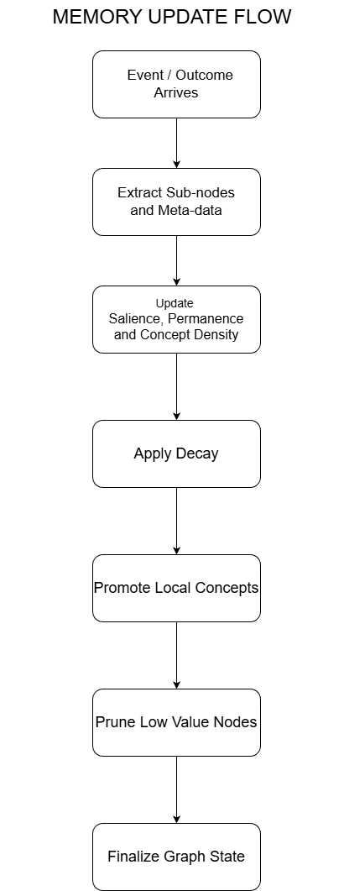
----------------------------------------------------------------------------------------------------------
4. Update Dynamics: How Memory Changes
----------------------------------------------------------------------------------------------------------
If the data model defines what memory is, the update rules define how memory behaves. This is the part most “memory systems” never solve. They store things. They retrieve things. But they don’t change themselves. Real memory, in contrast, is shaped by every interaction. Experience continuously rearranges the structure subtly, almost invisibly, until the system becomes the sum of its history.
The substrate follows the same principle. Every event, every outcome, every retrieval nudges the structure slightly. Some nodes strengthen. Some edges fade. Some trajectories stabilize into long-term knowledge. Others dissolve into noise. Over time, these microscopic updates create a macro-level identity.
The following sections describe the mechanics behind those updates.

Event Integration: Folding New Experience Into the Structure
When the agent records a new event, the substrate performs a short integration cycle—small, cheap, but meaningful. A new event node is created (unless a pattern matches an existing concept strongly enough to reinforce it). New experiences deserve a place in the graph, even if they later fade.Temporal edges update automatically. The new event links to the previous one in the current episode, preserving order and enabling deterministic replay. Initial salience is high. Every new event starts out “loud”—a small novelty bias that gives fresh trajectories a chance to matter. Nearby memories decay slightly. As something new happens, related but unused memories lose a bit of strength. This allows relevance to migrate naturally toward ongoing experience.
Event integration keeps the substrate grounded in the present without overpowering the larger structure. Only repeated reinforcement or meaningful outcomes will push an event from “recent experience” to “long-term memory.”

Outcome Integration: Where Learning Actually Happens
When an outcome arrives—good or bad—the substrate reorganizes itself. This is the core learning mechanism, the moment when the system says: “This mattered.” The integration process unfolds in several steps: The relevant event or episode is identified. Usually the last action, but sometimes a small chain of preceding events. Causal edges strengthen or weaken. Positive outcomes increase salience and permanence across the responsible trajectory. Negative outcomes increase permanence far more than salience—failures stick, even after their emotional intensity fades. Influence propagates backward. A mild, controlled backward pressure updates upstream nodes and edges. This prevents the “last event gets all the credit” problem. Decay rates adjust. Catastrophic outcomes remain vibrant in memory for a long time.Mild consequences fade naturally, neutral results disappear quickly.
Outcome integration is the substrate’s equivalent of learning through consequence. It is how the system forms preferences, avoids repeated harm, and develops long-horizon behavioral stability.

Retrieval-Based Reinforcement: Memory Strengthens When Used
Humans reinforce memory by thinking about something. This substrate adapts the structure in the same way. Any time the agent queries the lattice—whether through get_context(), get_similar_cases(), an internal reasoning operation, or an explanation request—the referenced nodes and edges receive a small boost: salience rises, decay slows, and core concepts gain permanence over time. This creates a feedback loop:
The more the agent leans on a memory, the more that memory becomes part of how the agent thinks.
Identity emerges from repeated use, not static encoding.

Salience: The System’s Sense of Attention
Salience is the substrate’s way of deciding what deserves attention right now. It isn’t a score handed down by an engineer, it’s a living signal that rises and falls as the agent interacts with the world. When something is fresh, relevant, or repeatedly referenced, its salience moves upward. When the system drifts away from it, salience relaxes and allows other experiences to take precedence.
In practice, salience behaves like short-term cognitive gravity. Recent events pull the agent’s reasoning toward them, and strong outcomes can keep an otherwise ordinary moment in the foreground far longer than expected. At the same time, salience naturally settles unless reinforced; no memory should stay at full intensity forever.
This short-horizon fluidity is what allows the substrate to adapt quickly without rewriting its deeper structure. Salience highlights what the agent is paying attention to in the moment, and it quietly reshapes the lattice to keep pace with shifting context. It is not the final word on importance—permanence handles that—but it is the mechanism that keeps memory and perception synchronized.

Permanence Dynamics: Temporal Stickiness
Where salience is short-term attention, permanence is long-term consolidation. It shifts slowly and cautiously. Strong outcomes raise permanence. Especially sharp successes or failures.Changing environments reduce permanence. Slowly, gently, so the agent remains adaptable. High-permanence nodes survive pruning. They become the core scaffolding of the agent’s internal world.
Permanence gives the substrate a stable spine—memories that persist not because they are recent, but because they matter.

Decay Dynamics: Information Compression
Decay is not a failure mode, it’s a contextual imperative in the process of discovering meaning in noise. Decay applies to everything within the structure that isn’t seeded with permanence. It follows a few intuitive rules:
- Unused memory fades.
If it never comes up, it can be allowed to be forgotten.
- Decay is nonlinear.
Trivial events disappear quickly.
Important events decay slowly.
Concepts decay based on usage patterns.
Episodes fade when their context drifts.
- Decay never deletes anything outright.
It only moves items toward the pruning threshold.
Decay keeps the substrate dynamic, letting relevance emerge organically instead of being dictated manually.

Pruning Mechanics: Keeping Memory Healthy
Pruning enforces boundedness, but it is never arbitrary. The substrate does not forget because it ran out of space. It forgets because some memories are no longer worth carrying.
A node or edge is pruned only when:
- salience is low,
- permanence is low,
- usage is low,
- structural connectivity is weak,
- and its contribution to trajectories is minimal.
Pruning is structural maintenance: removing dead branches so the lattice can remain coherent, navigable, and finite. Several rules ensure critical experience is never lost; catastrophic outcomes persist, high-permanence nodes are protected, pruning triggers local rebalancing to avoid destabilizing the graph, pruning is deterministic given the substrate state, to name a few obvious examples. This keeps the system lean without erasing what defines the agent.

Conceptual Density: Structural Importance
Some parts of memory matter not because they are recent or emotionally charged, but because tearing them out would break everything around them. Conceptual density captures this idea. It reflects how deeply a node, whether it be an event, a concept, or a subnode, participates in the substrate’s internal web of meaning. A dense node is one that sits at the center of many connections, influences multiple abstractions, or acts as a bridge between otherwise distant regions of experience.
This is different from salience and permanence. A memory can be quiet and old, yet still essential because too much depends on it. Likewise, a node can be vivid but structurally shallow. Density measures integration, and creates hubs for associative reasoning.
By incorporating density into the update process, the substrate develops a kind of architectural intuition. It begins to distinguish between surface-level impressions and the deeper scaffolding that holds the agent’s worldview together. Nodes with high density become naturally resistant to pruning, even when their salience has faded. Sparse nodes remain fragile unless reinforced by actual experience. Over time, this encourages the lattice to organize itself around stable conceptual anchors rather than drifting toward whatever the agent happened to encounter last.
This also gives the system a principled path for abstraction. When a recurring pattern begins connecting across many events and subnodes, density accumulates until it effectively changes into a concept an emergent structure that the agent did not explicitly design. Conversely, when a once-dense region stops receiving reinforcement, its internal connections gradually unwind, and the concept dissolves back into ordinary experience.
Conceptual density is what makes the Yggdrasil architecture resilient. It keeps the structure coherent even as the agent accumulates thousands of interactions. And it ensures that long-lived understanding (categories, distinctions, intuitions) survives long after the initial circumstances have passed.
In practice, concept nodes can be promoted from dense clusters of related events based on co-occurrence, connectivity, and similarity statistics, with optional model-derived labels used for interpretability. The exact promotion and refinement strategies are implementation-specific and left to future work.

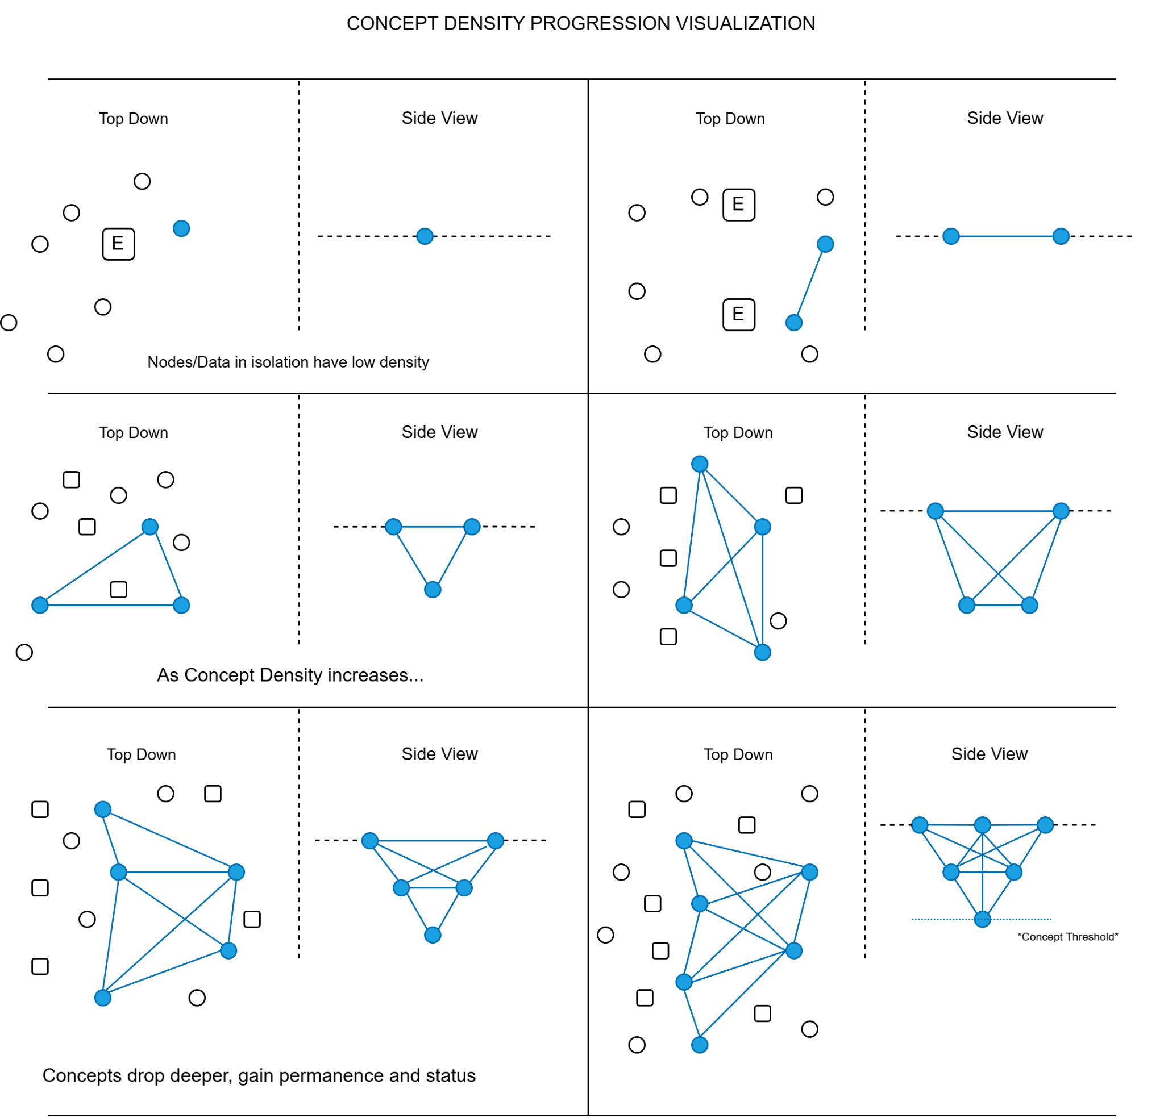

Handling Novelty: Encouraging Exploration Without Chaos
Novelty is essential for learning, but potentially problematic if left unchecked. The substrate manages novelty through a controlled set of biases:
- New events receive a salience boost.
- Novel transitions begin with low permanence but high exploratory value.
- New concepts start fragile, strengthening only when reinforced.
- Novel outcomes shape the substrate aggressively to capture early signals.
This creates a natural balance: the agent is free to explore, but not free to destabilize its entire memory structure with every new observation. It also opens the doors to creativity, non-linear ideation, associative solution matching, and more.

Closing Section 4
These update dynamics are the laws of motion for the Lattice Memory Architecture.
They dictate how experiences become structure, how structure shapes identity, and how identity evolves with continued interaction. They turn memory into something governed, not chaotic; adaptive, not static; finite, not sprawling.
With these rules in place, the substrate becomes a stable foundation for agents and LLMs to interact with safely.
The next section introduces the small, strict API that models and controllers use to query and contribute to memory without compromising its integrity.
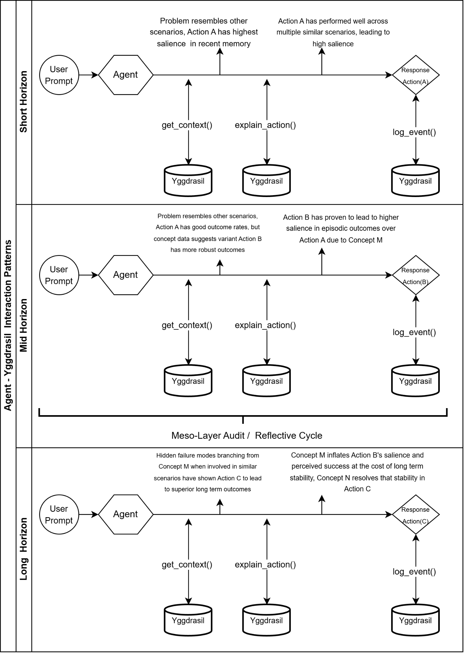

----------------------------------------------------------------------------------------
5. API Layer for Agent and LLM Interaction
-----------------------------------------------------------------------------------------

A memory substrate is only as useful as the interface through which an agent interacts with it. The substrate must expose a small, carefully chosen set of operations—simple enough that an LLM cannot misuse them, expressive enough to support sophisticated reasoning, and stable enough to guarantee deterministic behavior across time.
This section defines the API surface that governs how agent logic and memory interact.

Design Principles
The API follows a strict set of principles:

1. Simplicity and determinism
All calls must produce deterministic and inspectable outcomes. LLMs cannot be allowed to mutate memory arbitrarily.

2. Separation of concerns
Agents do not manipulate the memory graph directly. They request operations; the substrate performs updates internally. This system of checks and balances is necessary to avoid warping meaning and weight over time.

3. Limited affordances
Fewer operations reduce the risk of incoherence. The substrate should be hard to misuse.

4. Symmetry with human cognition
The API mirrors aspects of what human memory accomplishes. Storage, recall, and association give rise to reflection. With reflection, long term iteration through similar episodes and events becomes feasible without expensive backward propagation or retraining cycles.

5. Full auditability
Every API call becomes part of the event log, allowing for human interface and governance over the evolution of the substrate.

Core API Methods

record_event(event_payload, metadata=None)
Records a new event into short-term memory or directly into the substrate when appropriate. This is an active field for research, qualifications for event status. The following would occur, at a minimum:
- Create an event node
- Connect it to previous events via temporal edges and conceptual/associative values.
- Apply novelty salience dependent on the uniqueness of the situation.
- Initiates decay on competing nodes in the structure.
- Returns a stable event_id for later reference
This is how the agent pushes new events to memory and creates forward temporal pressure on lived experience via the boundedness principles of the structure.

log_outcome(event_id, outcome_payload)
Associates an outcome with a past event or trajectory, maintaining sequence order between actions and outcomes. This would trigger:
- outcome integration
- salience/permanence updates
- backward propagation
- decay rate modulation
- potential conceptual updates
This is how the structure and agent create sequences of cause and effect that can be referred to and associated with.

get_context(query, k=None)
Retrieves relevant nodes, episodes, or concepts Contextual recall is then based on:
- associative edges
- salience
- permanence
- recency
- conceptual similarity
If vector embeddings are used, they are attached to events and concepts at ingestion time by upstream models, not generated inside the substrate itself. The substrate may use these stored embeddings as one more similarity channel during retrieval, but it remains agnostic to how they were produced.
LLMs receive structured memory objects (events, episodes, concepts, and their annotations), never raw graph state, and cannot directly manipulate the substrate. Behavior is modulated by which memories are retrieved and how they are framed, not by rewriting weights. This is how the agent adapts over time without retraining, develops long-term associative behavior, and can support richer generalization from experience.

explain_action(action_id)
Returns the memory lineage that led to a given decision.
Provides:
- relevant nodes
- relevant outcomes
- causal edges
- salience/permanence evidence
- the deterministic trace
This enables:
- debugging
- governance
- interpretability
- post-hoc analysis
- deterministic replay
This is how the deterministic nature of the structure allows for both agentic creativity with coherence, and for human-in-the-loop checks on how the substrate structure is evolving with respect to the experiential changes agents experience.

Optional / Extended API Methods
These are not required for v1 but often useful.

snapshot()
Creates a stable snapshot of the substrate for fast replay.

restore(snapshot)
Restores the substrate to a prior state for evaluation or simulation.

get_similar_cases(context, k)
Retrieves analogous trajectories, episodes, or outcomes.
Useful for:
- planning
- reasoning
- “what should I do now?” decisions

What the API Does Not Allow
This is important for safety and coherence. The agent cannot:
- directly edit nodes
- manipulate edges
- override salience or permanence
- delete memories
- break boundedness
- mutate structure arbitrarily
All adaptation and experiential data flows through record_event or log_outcome. This guarantees many things, such as determinism, cognitive stability, replayability, safety, and substrate integrity. And ensures that models—especially LLMs—operate within strict guardrails, while still reaping the benefits of the structure.

-------------------------------------------------------------------------------------------------------
6. Episodic Chunking and Short-Term Experience
-------------------------------------------------------------------------------------------------------
Intelligence doesn’t emerge from raw events. That’s just noise. What matters is how those events get shaped into something with continuity—how they’re grouped, compressed, and stored in a way that preserves meaning rather than overwhelm. Humans don’t archive every second of their lives; they compress experience into episodes that capture what mattered in context.
The memory substrate uses the same idea. Episode chunking is the mechanism that turns short-term streams of events into stable long-term structures. Without chunking, memory would collapse into an endless list of micro-observations. With it, the system gains something closer to understanding.
Chunking is the bridge between “what just happened” and “what this means.”
Short-Term Experience Buffer
Every new interaction begins in a short-term buffer essentially the working memory of the system. It’s intentionally lightweight and permissive: it holds raw events with full temporal ordering, grows freely over short windows, contains no abstraction, compression, or pruning mechanics and it hasn’t yet been shaped by outcomes. This could be related to the present moment, or the moment of attention. As the agent works, the short term buffer allows it to access memory in order to change behavior from one event to the next, external or internal to the episode it is currently operating in. The buffer collects everything passing through the agent’s perception loop:
- observations
- decisions
- environmental signals
- intermediate states
- metadata
The important thing is this: the buffer is not memory. It is the staging ground from which memory might be formed, if experience warrants it and the memory structure defines it as beneficial to the overall structure.

When the System Decides to Chunk
Chunking is not random and not driven by superficial timing. The substrate watches the shape of short-term experience and commits an episode only when the flow reaches a meaningful boundary. Typical triggers include:
- The completion of a full interaction cycle
(action → outcome → response).
- A natural semantic boundary
ending a task, finishing a user session, switching goals.
- The arrival of a meaningful outcome
especially a high-salience success or failure.
- Buffer pressure: The short-term sequence simply becomes too large to be useful raw.
- Pattern-driven thresholds
repeated state configurations that historically lead to chunking.
Chunking is deterministic.It reflects clear structure in the agent’s flow of experience, not heuristic guesswork. It also represents a point of research, defining how to most optimally break experiences into temporally coherent chunks for analysis in non-stationary environments.

How Chunking Works
When the substrate decides an episode should exist, chunking proceeds in a few carefully ordered steps:
- Extract the raw event sequence.
All events in the buffer are pulled out in temporal order.
- Create an episode block.
This block encapsulates the events that comprise the episode:
  - the context
  - the salient transitions
  - any emerging conceptual structure
  - potential or realized outcomes
- Link the episode to its underlying events.
Episodes don’t hide detail; they abstract it with full transparency.
- Propagate salience upward.
Impactful events lend weight to the episode’s initial salience.
- Bind the episode into the long-term lattice.
This includes:
  - temporal edges to previous episodes
  - associative links to relevant concepts
  - potential causal relationships
- Clear (or partially clear) the buffer.
Depending on configuration:
  - full reset
  - sliding window
  - retention of key events for the next chunk
Chunking is fully reversible via deterministic replay.
You can always reconstruct the raw event stream beneath the abstraction.
Chunking is what allows for hierarchical understanding of events to outcomes, intelligent analysis of causal relationships in between decisions and long term outcomes, and temporal coherence over the course of complex actions. It benefits the system with the following:
Structural Compression. Hundreds of low-level events can become a single coherent unit.
Retrieval Becomes Useful. Episodes form the building blocks of context, guidance, and recall.
Outcome Attribution Improves, as most consequences come from trajectories, not isolated events.
Memory Dissonance is Alleviated; without chunking, long-term memory becomes a monotonically growing chain of noise.
High-Level Reasoning Emerges. Agents can be enabled to think in terms of: strategies, patterns, episodes, trajectories, or coherence between embedding distributions, predicted solutions, and experientially backed results, rather than isolated ticks of observation
Chunking is how raw experience within a complex system of action and reaction becomes something structured enough to guide behavior.

Episode Aging and Refinement
Episodes are not fixed snapshots frozen in time, as the components within are subject to the conceptual, associative and pruning rules of the system. Over time, an episode may acquire new outcome links, causing it to adjust its conceptual associations or shift in salience through decay or reinforcement. They can gain permanence through retrieval, which allows disjoint or singular experiences to change roles as future episodes reveal new relationships. Episodes, and all other levels of the system, gain weight or fade.
They move from short-term significance to long-term understanding or disappear entirely.
This refinement process is how long-horizon preferences, instincts, and behavioral biases emerge.The substrate doesn’t just remember episodes. It adapts them as experience continues, allowing for higher dimensionalities of understanding and intelligence.

-------------------------------------------------
7. Core Data Structures
-------------------------------------------------

Node Class
class Node:
def __init__(self, node_type, payload, timestamp):
self.id = uuid4()
self.type = node_type # event, episode, concept, outcome
self.payload = payload
self.timestamp = timestamp

# Dynamic attributes
self.salience = 1.0
self.permanence = 0.0
self.decay_rate = 0.01
self.usage = 0
self.edges = [] # outgoing edges

def reinforce(self, amount):
self.salience += amount
self.usage += 1
self.decay_rate *= 0.98 # slow decay on use

def decay_step(self):
self.salience = max(0, self.salience - self.decay_rate)

Edge Class
class Edge:
def __init__(self, src, dst, edge_type):
self.id = uuid4()
self.src = src
self.dst = dst
self.type = edge_type # temporal, causal, associative
self.weight = 1.0
self.permanence = 0.0
self.decay_rate = 0.01

def reinforce(self, amount):
self.weight += amount
self.decay_rate *= 0.98

def decay_step(self):
self.weight = max(0, self.weight - self.decay_rate)

Nodes and edges are simple objects with adaptive attributes.
Most of the behavior emerges from the substrate’s update loop.

Substrate Structure
class MemorySubstrate:
def __init__(self, max_nodes=50000):
self.nodes = {}
self.edges = {}
self.max_nodes = max_nodes
self.short_term_buffer = []
self.event_log = []
self.last_event = None

The substrate maintains:
- a global node/edge store
- a short-term buffer
- an event log for replay
- a strict upper bound on memory size

Core Update Loop

Record an Event
def record_event(self, payload, metadata=None):
event = Node("event", payload, now())
self.nodes[event.id] = event

# Connect to last event via temporal edge
if self.last_event:
edge = Edge(self.last_event.id, event.id, "temporal")
self.edges[edge.id] = edge
self.last_event.edges.append(edge)

# Short-term buffer integration
self.short_term_buffer.append(event.id)
self.last_event = event

# Apply novelty salience
event.salience += 0.5

# Apply broad background decay
self.apply_decay()

# Log event
self.event_log.append(("record_event", event.id))

return event.id

Key points:
- deterministic
- minimal mutation
- bounded side effects
- salience and decay handled automatically

Log an Outcome
def log_outcome(self, event_id, outcome_payload):
outcome = Node("outcome", outcome_payload, now())
self.nodes[outcome.id] = outcome

# Create causal edge
edge = Edge(event_id, outcome.id, "causal")
self.edges[edge.id] = edge

# Outcome shaping
# Positive/negative values influence reinforcement strength
magnitude = outcome_payload.get("value", 0)

if magnitude > 0:
self.reinforce_positive(event_id, outcome.id, magnitude)
else:
self.reinforce_negative(event_id, outcome.id, -magnitude)

# Log outcome
self.event_log.append(("log_outcome", event_id, outcome.id))

return outcome.id

Outcome integration routes through two controlled paths:
- positive reinforcement
- negative high-permanence encoding

Outcome Dynamics
def reinforce_positive(self, event_id, outcome_id, magnitude):
event = self.nodes[event_id]

# Strengthen local memory
event.reinforce(magnitude * 0.5)

# Increase permanence moderately
event.permanence += magnitude * 0.1

# Propagate slightly backward
for eid in reversed(self.short_term_buffer[-5:]):
if eid == event_id:
continue
self.nodes[eid].reinforce(magnitude * 0.1)

def reinforce_negative(self, event_id, outcome_id, magnitude):
event = self.nodes[event_id]

# Strong permanence boost for failures
event.permanence += magnitude * 0.5

# Salience spike (short-lived)
event.salience += magnitude

# Slower decay for associated edges
for edge in event.edges:
edge.decay_rate *= 0.7

This mirrors human-like asymmetry: failure is encoded strongly; success is encoded directionally.

Decay, Pruning, and Boundedness

Decay Loop
def apply_decay(self):
for node in self.nodes.values():
node.decay_step()
for edge in self.edges.values():
edge.decay_step()

Pruning Mechanism
def prune_if_needed(self):
if len(self.nodes) <= self.max_nodes:
return

# Rank nodes by salience, permanence, usage
candidates = sorted(
self.nodes.values(),
key=lambda n: (n.permanence, n.salience, n.usage)
)

# Remove the weakest nodes
to_remove = len(self.nodes) - self.max_nodes
for node in candidates[:to_remove]:
self.delete_node(node.id)

Delete Node
def delete_node(self, node_id):
# Remove edges attached to this node
for edge_id, edge in list(self.edges.items()):
if edge.src == node_id or edge.dst == node_id:
del self.edges[edge_id]

del self.nodes[node_id]

Pruning is deterministic and rule-based, never random.

Retrieval & Explanation

Get Context
def get_context(self, query, k=5):
# Simple similarity via payload or embeddings
scored = []
for node in self.nodes.values():
sim = similarity(node.payload, query)
score = sim + node.salience + (0.5 * node.permanence)
scored.append((score, node))

top = sorted(scored, key=lambda x: x[0], reverse=True)[:k]

# Retrieval reinforces usage
for _, node in top:
node.reinforce(0.1)

return [node for _, node in top]

Explain Action
def explain_action(self, action_id):
# Walk backward via temporal edges
trace = []
current = self.nodes[action_id]

while current:
trace.append(current)
prev_edge = self._get_prev_temporal_edge(current.id)
if not prev_edge:
break
current = self.nodes.get(prev_edge.src)

return trace[::-1] # earliest → latest

This gives full replayable lineage.

Example Usage
# Agent takes an action
eid = substrate.record_event({"action": "send_offer"})

# Later, an outcome is observed
oid = substrate.log_outcome(eid, {"value": -1, "reason": "user_unsubscribed"})

# Agent retrieves context for next decision
context = substrate.get_context({"goal": "retain_user"})

This minimal example shows the end-to-end flow of:
- experience
- learning
- retrieval
- adaptation
Without exposing any low-level graph manipulation to the agent. This reference implementation is intentionally minimal, as its purpose is to demonstrate that the substrate is mechanically simple, deterministic, and feasible to implement in a few hundred lines of real code, while still supporting the full adaptive dynamics described earlier.
The next section describes the meso-cognitive layer that audits the memory structure outside of the short-term buffer.

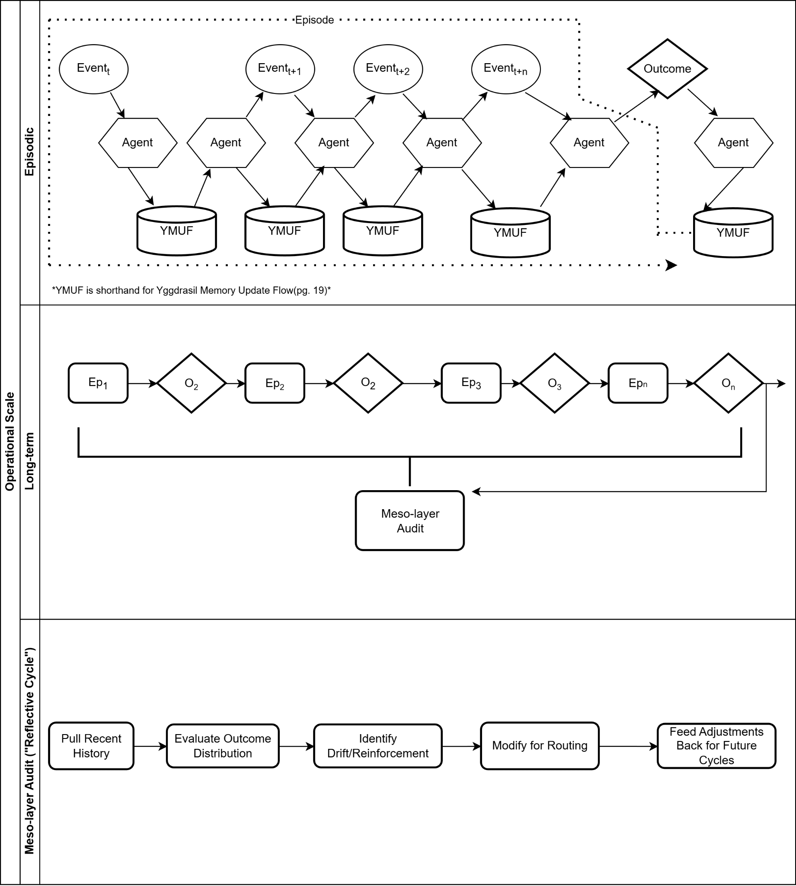

--------------------------------------------------------------------------------------------------------------------------------
8. The Meso-Cognitive Layer: Reflective Auditing Over Time
--------------------------------------------------------------------------------------------------------------------------------
Everything up to this point has focused on how the substrate responds locally: a new event comes in, an outcome lands, a retrieval occurs, and the structure updates. But human cognition doesn’t only operate at that “step-by-step” level. We also run slower, background processes that look back over what we’ve done and quietly ask:
- “Was that actually a good idea?”
- “Is this habit still helping me?”
- “Did I misunderstand why that went wrong?”
The Yggdrasil Memory Architecture includes an explicit analogue of that process: a meso-cognitive layer, a reflective auditor that periodically scans the structure, re-evaluates trajectories, and adjusts long-horizon behavior. By searching through the memory system, the event loop becomes the experiential continuum, and long term results of seemingly innocuous short term behaviors can alter the outcomes of reward seeking behavior.

Role of the Meso Layer
The meso layer sits between short-term experience and long-term structure. It runs on a slower timescale than the main agent loop and has a different job. It doesn’t make immediate decisions, or manage token-by-token reasoning. It doesn’t respond to every event or every series of events. It instead observes and adjusts the overall topology of the behavioral patterning of the agent. It accomplishes this by:
- reviewing episodes and trajectories
- comparing short-term wins vs long-term outcomes
- seeking hidden failure modes and false positives
- adjusts salience, permanence, and decay based on longer horizons
In other words, it gives the system something like a subconscious; an ongoing background process that keeps asking whether the current strategies still make sense given everything that has happened so far.
A standard meso-layer pass resembles like this, at a high level:
- Anchor selection
  - Start from the current context or a recently used episode.
  - Find similar episodes with high-salience outcomes (both positive and negative).
- Trajectory inspection
  - For each anchor, trace the key events and decisions that led to the outcome.
  - Pay particular attention to nodes and edges with high permanence.
- Pattern comparison
  - Compare “good” and “bad” trajectories that started from similar contexts.
  - Identify which intermediate decisions tend to lead toward robust long-term outcomes versus brittle short-term wins.
- Substrate updates
  - Slightly adjust salience, permanence, and decay along those trajectories.
  - Elevate intermediate decisions that consistently lead to healthy outcomes.
  - Demote paths that look good locally but degrade long-run behavior.
The key point is that the meso layer is not picking actions directly. It’s tightening and loosening the pathing of the structure so that future decisions, made by the normal agent loop, are gently nudged toward better long-horizon paths.

Long-Horizon Credit Assignment and Causal Correction
Short-term learning tends to over-credit the last few steps before an outcome. That’s true in RL, and it’s true in everyday reasoning. The meso layer exists partly to correct that. Over time, it can discover that a repeatedly rewarded behavior has a hidden long-term cost, or notice that some “lucky” successes are not actually robust, both of which are elusive, difficult to discover reactions to reactions. It also allows the system to recognize that a failure came from an earlier poor choice, not just the final move or action, and at the same time downgrade superficial correlations that don’t hold across episodes.
Practically, this looks like strengthening edges further back in the trajectory when they reliably precede good outcomes, or increasing salience for concepts that consistently predict good or bad futures, and reducing salience for edges that appear close to outcomes but don’t actually cause them. The result is a form of long-horizon credit assignment and causal cleanup. The substrate slowly rewrites its own understanding of why things happen, based not on single episodes, but on accumulated evidence across many.

Interaction With the Online Agent Loop
The meso layer runs in the background, on its own schedule. It doesn’t need to block the agent loop, and it doesn’t constantly intervene. Instead, it can periodically fire (e.g., after N episodes, or during idle periods), or quickly operate on a snapshot of the structure at that moment, and instead writes back small, incremental adjustments.
The online agent sees the effects indirectly:
- context queries (get_context, get_similar_cases) begin to return stronger long-horizon strategies more consistently
- short-term greedy actions that previously “worked” may gradually stop being favored
- explanations (explain_action) start to refer to deeper, more stable patterns, not just recent fragments
From the agent’s perspective, nothing magical happens. The substrate simply “gets wiser” over time.

Governance, Safety, and Stability
A background process that can rewrite the structure must be treated carefully. The meso layer is deliberately constrained:
- It does not create or destroy nodes arbitrarily.
- It operates through the same triad (salience, permanence, decay) as everything else.
- It respects boundedness and pruning rules.
- Its updates are logged, replayable, and auditable like any other substrate change.
This keeps the system from drifting or “hallucinating” new structure without grounding. The meso layer is reflective, not generative: it reinterprets existing experience instead of inventing new worlds.
From a safety perspective, this layer is also where:
- misaligned strategies can be detected and downgraded over long horizons
- drift in behavior can be monitored via replay and inspection
- guardrail violations can feed back into the substrate with high permanence so they are not repeated
Without this layer, the substrate still provides continuity, outcome-shaped learning, and bounded memory. But it remains mostly local in time: good at mapping recent experience, weaker at reconciling subtle, long-horizon dynamics. By integrating the meso layer, the system gains the ability to correct itself slowly, a method to notice patterns that only show up across many episodes and outcomes. It also provides a mechanism for preferring “boring but robust” strategies over flashy short-term tricks, and eventually, it may exhibit the beginnings of what looks, from the outside, like instinct or judgment.
It’s not “consciousness,” and it’s not trying to be. But it is a practical way to give an artificial agent a second chance to rethink what it has been doing, adjust over time, while remaining grounded in real experience.
The meso-cognitive layer turns the Yggdrasil Memory Architecture from a reactive memory system into a reflective one, as it doesn’t just remember; it periodically re-evaluates its own history and reshapes the structure to favor strategies that hold up over time. In combination with the core substrate and API, this layer pushes the architecture closer to something that can develop stable, adaptive behavior in complex environments.
The next sections discuss broader implications, limitations, and future directions, and provide a minimal reference implementation to ground this design in executable form.

-------------------------------------------------------------------------------------------------------------------------------
9. Behavioral Characteristics and Emergent Properties
-------------------------------------------------------------------------------------------------------------------------------
A memory substrate is only meaningful if it produces stable, interpretable behavior that improves over time. The system described here is not just a new data model — it is a set of interacting dynamics that collectively generate cognitive properties no retrieval system can approximate. The key point is simple: once an agent has a structured, evolving internal world, its behavior begins to reflect continuity. And continuity is the precursor to identity, preference, intuition, and long-term adaptability.
The subsections below outline some of the most significant emergent behaviors produced by the Yggdrasil substrate.

Continuity and Identity Formation
Because memory is shaped by consequences and reinforced through retrieval and use, two agents with identical architectures diverge immediately when their experiences differ.
Agents backed by this substrate can be expected to develop consistent tendencies and stable behavioral biases. Over experiences, either pre-seeded or truly experiential, internalized “lessons learned” will lead to meaningful aversions and recognizable strategies. Identity is not a programmed model or precept of personality quirks. It emerges as a direct consequence of the substrate’s update laws.

Divergent Trajectories From Small Differences
Minor differences in experience produce major differences in long-term behavior, because each perturbation propagates through salience, inflecting permanence and conceptual density, triggering overt changes to the causal structure of the graph. Episode chunking and retrieval reinforcement lead to completely divergent memory structures when exposed to varying stimuli from different environments.
This mirrors biological cognition: subjective experience creates individualized internal models, lending weight to the premise that two agents exposed to different:
- examples
- environments
- outcomes
- corrections
These differences develop distinct memory graphs and therefore distinct behavioral patterns and ‘identities’. Adaptation, then, becomes the defining nature of intelligence, not memorization or more precise embeddings.
Stable Long-Term Learning
Unlike RAG or vector databases where everything is “flat”, the substrate organizes experience hierarchically and weights it through consequence and density. Outcome integration and retrieval reinforcement produce reliable long-term learning; successful trajectories are repeated, harmful sequences are avoided. High-permanence concepts anchor behavior to experientially grounded, adaptive constructs, while decayed or unused paths naturally fade
Critically, this learning does not come from SGD or external fine-tuning. It emerges directly from the substrate’s rules, bypassing the need for lengthy training and backpropagation cycles. This will ostensibly lend agents a stability and generalization profile that LLM-centric agents typically lack.

Emergent “Intuition” via Weighted Associations
Over time, the substrate develops weighted associative structures:
- common transitions
- co-occurring concepts
- reinforced causal chains
- stable outcome pathways
These structures allow the agent to anticipate consequences, infer reasonable or orthogonal actions, trace concepts and episodic similarity in order to generalize to new contexts. Unlike human intuition, which is often influenced by emotional, instinctive, or opaque heuristics, these associations provide a traceable, deterministic basis for anticipatory judgment.
The memory substrate achieves cognitive properties without massive parameter counts, heavy training, or brittle prompt engineering. Intelligence arises from the interplay of boundedness, salience, permanence, decay, and deterministic consequence-driven updates — not architectural complexity.
These emergent behaviors demonstrate that a governed memory substrate can produce coherent, adaptive agents capable of long-term stability and meaningful improvement over time.
The next section situates this architecture in the landscape of existing memory and cognition research, clarifying both inspiration and departure from prior approaches.

10. Related Work and Integration With Existing Systems
Memory has appeared across multiple domains in AI—retrieval systems, reinforcement learning, cognitive architectures, differentiable memory networks—but almost always as a component or optimization trick, not as a governed substrate for agent continuity. Yggdrasil occupies a different conceptual space: it is a systems-level memory architecture designed to support long-horizon coherence, identity formation, and outcome-shaped learning.
Where Section 2 focused on the limitations of current approaches, this section reframes those technologies in terms of how they fit alongside a true memory substrate, and how Yggdrasil extends or complements them rather than replacing them.

Positioning Within Prior Research

Vector Databases and RAG Systems
Vector search and retrieval pipelines remain powerful tools for accessing information. They excel at similarity lookup, document grounding, and knowledge retrieval. What they do not provide—and were never designed to provide—is governed internal structure or adaptive continuity. Yggdrasil complements these tools by giving agents a stable memory substrate that can decide when similarity search or external retrieval is appropriate, and how retrieved information should reshape future behavior.

Transformer Context and Extended Windows
Long context windows improve an agent’s working memory but cannot serve as long-term memory. They offer transient state, not evolving structure. Yggdrasil can use the transformer’s context selectively, pulling in only the relevant episodes or concepts that the substrate identifies as important, rather than relying on brute-force transcript stuffing.

RL Replay Buffers
Replay buffers store experiences for training loops but do not produce a structured internal history or identity. Yggdrasil provides the governed, conceptual, outcome-shaped memory layer that replay buffers were never meant to address. The two can coexist: RL agents can still train from transitions, but their operational reasoning becomes grounded in the substrate’s long-term structure.
Cognitive Architectures (SOAR, ACT-R)
Classical symbolic architectures treat memory as a structured entity but rely on predefined rules and fixed chunking strategies. Yggdrasil differs by using event sourcing, adaptive salience/permanence, and continuous graph evolution—governed, but not hand-coded. It integrates with learned systems rather than replacing them with symbolic constructions.

Differentiable Memory Networks (NTM, DNC, etc.)
Neural memory modules offer differentiable read/write capabilities for learned models, but require gradient-based training and lack interpretability, permanence, or governance. Yggdrasil stands outside the differentiable paradigm entirely: it is a non-differentiable, deterministic, inspectable memory substrate meant to support agent cognition rather than model training.

Agent Scratchpads and Textual Logs
Scratchpads and logs are useful short-term tools for reasoning, but they grow unbounded and do not form a structured or governed internal model. Yggdrasil provides the scaffolding needed to convert short-term notes into stable, contextualized experience without relying on ever-growing transcripts.

Summary of Distinctions
Across decades of research, no existing approach has offered:
- a governed system for determining what should be remembered or forgotten
- an event-sourced, replayable model of the agent’s internal evolution
- salience/permanence dynamics shaped by outcomes
- episodic abstraction
- concept formation over time
- backward credit assignment
- bounded yet adaptive structure
- a minimal, stable API designed for agent interaction
Yggdrasil attempts to fill this gap by acting as a general-purpose cognitive memory layer—a substrate capable of shaping continuity, identity, and long-horizon reasoning.

How Yggdrasil Enhances Existing Retrieval and Working-Memory Tools
The goal of this architecture is not to replace RAG, vector search, long context windows, or scratchpads. It is to give an agent a principled internal structure that allows these tools to be used intelligently rather than indiscriminately.

Similarity Search Becomes Contextual
Instead of relying on embedding similarity as a default retrieval strategy, Yggdrasil enables agents to decide when similarity is actually relevant:
- based on past outcomes
- based on conceptual structure
- based on trajectory context
It moves vector search from “always on” to “strategically deployed.”

RAG Becomes an Accuracy Mechanism, Not a Memory Substitute
Under Yggdrasil, RAG functions like an external lookup:
- invoked when the substrate signals uncertainty
- integrated according to salience/permanence rules
- used to fill gaps rather than impersonate long-term memory
RAG strengthens reasoning without pretending to store experiential identity.

Long Context Becomes Efficient Rather Than Bloated
Instead of dumping entire transcripts into the prompt:
- Yggdrasil retrieves only relevant episodes or concepts
- the context window becomes a working buffer, not a surrogate identity
- coherence persists even after the buffer resets
This dramatically reduces prompt bloat and improves determinism.

Logs and Scratchpads Become Short-Term Scaffolding
Agents can still use short-term notes for reasoning, but:
- scratchpad entries are distilled into the substrate
- unimportant details decay naturally
- logs no longer need to accumulate indefinitely
The agent stops depending on loose transcripts to maintain coherence.

Tool Selection Becomes an Experiential Choice
With a governed memory substrate, the agent can learn:
- when retrieval is better than extrapolation
- which retrieval method to prefer in specific contexts
- how external knowledge should shift future behavior
- what kind of uncertainty should trigger a RAG call
- why certain tools succeed or fail in different scenarios
Yggdrasil transforms retrieval utilities from passive infrastructure into active cognitive skills shaped by experience.

Closing Section 10
While individual components of memory have been explored—retrieval, caching, replay, symbolic rule systems—none provide a coherent substrate for long-horizon adaptive intelligence. Yggdrasil fills this gap by offering a governed, event-sourced memory architecture capable of supporting continuity, identity, and experiential learning.
The next section examines the broader implications of this approach and its potential impact on both research and real-world agent design.

Conclusion and Future Directions
The primary limitations of modern AI systems do not stem from insufficient model capacity, inadequate compute, or a lack of data. They stem from the absence of a coherent, governed mechanism for long-term memory. Retrieval pipelines, extended context windows, token caching strategies, and “reflection” loops all attempt to compensate for this deficit — but none address the underlying problem. Without structure, consequence, and continuity, an agent cannot form a stable internal world model. Without a stable world model, it cannot adapt reliably, cannot retain long-term knowledge, and cannot behave coherently across time.
The memory substrate introduced in this paper is a first attempt to define such a mechanism. It is not a neural architecture. It is not a retrieval system. It is a systems-level data substrate designed to serve as the experiential backbone of artificial agents. By integrating salience, permanence, decay, pruning, episode chunking, deterministic replay, and outcome-shaped structure, the substrate provides a stable yet adaptive foundation upon which meaningful behavior can emerge.:

Adaptive Learning Without Heavy Optimization
Learning emerges directly from experience rather than being injected through gradient-based updates. The substrate expands what an agent can become without requiring architectural complexity or continual fine-tuning.
This work does not claim to provide a full cognitive stack. It introduces a foundation. Many directions remain open, including:
- Richer Concept Formation
Tools for automatic emergence of higher-level concepts from repeated trajectories and episodes.
- Multi-Agent Memory Exchange
Mechanisms for controlled sharing, merging, or partial inheritance of memories — enabling collaborative or collective intelligence.
- Memory Compression and Rewriting
Investigating whether the substrate can autonomously reorganize itself as patterns stabilize or when environments shift.
- Integration with Planners and World Models
Coupling the substrate with model-based RL, search algorithms, or LLM-driven planners to enable deeper multi-step reasoning grounded in internal continuity.
- Extended Governance and Safety Layers
Developing checks for memory drift, pathological loops, identity collapse, or harmful behavior patterns.
- Real-World Benchmarks
Creating evaluation environments that require long-horizon adaptation, identity formation, stable strategy, and replayable decision traces.
- Cross-Domain Applications
Testing the architecture across diverse settings, including:
- retention and marketing decision engines
- trading agents
- robotics and embodied control
- operational task planning
- multi-step conversational agents
Because the substrate is domain-agnostic, its value increases with application diversity.

In Closing
If artificial agents are ever going to exhibit coherent behavior across time — if they are ever going to stabilize their strategies, learn from experience, or justify their decisions — they cannot rely on prompt engineering or retrieval tricks. They need a memory substrate: one that evolves with experience, reinforces what matters, forgets what doesn’t, and grounds their internal world in a governed, interpretable structure.
This work offers a blueprint for such a substrate.The next stage is empirical: implementation, experimentation, and rigorous exploration of how far memory-driven architectures can push agentic intelligence. If memory is the missing layer in modern AI systems, this substrate provides the foundation on which the next generation of agents can be built.

